## A SEMINAR REPORT ON DEPRESSION ANALYSIS USING CONVOLUTIONARY NURAL NETWORKS

**SUBMITTED TO THE SAVITRIBAI PHULE PUNE UNIVERSITY, PUNE IN THE**

**PARTIAL FULFILLMENT OF THE REQUIREMENTS FOR THE AWARD OF THEDEGREE**

**OF**

**BACHELOR OF ENGINEERING (ELECTRONICS ANDTELECOMMUNICATION)**

**BY**

|  |  |
| --- | --- |
| **Mr. DAHALE AASHISH SHISHIRKANT** | **ExamNo.B150423021** |
| **Ms. SHREYA THAKUR** | **ExamNo.B150423097** |
| **Ms. GAUTAM THAKUR** | **ExamNo.B150423028** |

**UNDER THE GUIDANCE OF**

**PROF- Dr. R. V. BABAR**



**DEPARTMENT OF ELECTRONICS AND TELECOMMUNICATION**

**STES'S**

**SINHGAD INSTUTUTE OF TECHNOLOGY**

**Lonavala, 410401**



# CERTIFICATE

This is to certify that the Seminar report entitled

## INTELLIGENT TRANSPORT SYSTEM BASED VEHICLE TO VEHICLE

**COMMUNICATION**

**Submitted by**

|  |  |
| --- | --- |
| **Mr. DAHALE AASHISH SHISHIRKANT** | **Exam No.B150423021** |
| **Ms. SHREYA THAKUR** | **ExamNo.B150423097** |
| **Ms. GAUTAM THAKUR** | **ExamNo.B150423028** |

is a bonafide work carried out by them under the supervision of **Prof. Dr. R. V. BABAR**and it is approved for the partial fulfilment of the requirement of SavitribaiPhule Pune University, Pune for the award of the Degree of Bachelor of Engineering (Electronics and Telecommunication Engg).

This seminar report has not been earlier submitted to any other institute or university for the award of any degree ordiploma.

Prof.Dr.R.V.BABAR Dr.D.D.Chaudhary Dr. M. S.Gaikwad

Guide Head, Principal

DepartmentofE&T/C DepartmentofE&T/C Sinhgad Institute ofTechnolog

Lonavala

## Date: Place:Lonavala

**ExternalExaminer:**

**ACKNOWLGMENT**

We express our sense of gratitude towards our Project Guide **Prof. Dr.R.V.BABAR**for his valuable guidance and suggestions at every step of study of this Project Stage-I, also his contribution for the solution of every problem at each stage.

We are thankful to **Dr. D. D. Chaudhary** Head of the Department of Electronics and Telecommunication and all the staff members who extended the preparatory steps of this Project. We are very much thankful to respected Principal **Dr. M. S. Gaikwad**for his support and providing all facilities to complete theproject.

Finally we want to thank to all of our friends for their support & suggestions. Last but not the least we want to express thanks to our family for giving us support and confidence at each and every stage of this project.

**Project associates: -Mr.**DAHALE AASHISH S

**Ms.** SHREYA THAKUT **Ms.** GAUTAM THAKUR

# CONTENTS

|  |  |
| --- | --- |
| **CERTIFICATE** | **II** |
| **ACKNOWLEDGEMENT** | **III** |
| **LIST OF FIGURES** | **V** |
| **ABSTRACT** | **VI** |

|  |  |  |
| --- | --- | --- |
| CHAPTER | TITLE | PAGE NO. |
| 1 | INTRODUCTION | 8 |
| 1.1 | Objective | 8 |
| 1.2 | Overview | 8 |
| 1.3 | Organization of Project report | 9 |
| 2 | PROBLEM DEFINATION | 11 |
| 3 | LITERATURE SURVEY | 13 |
| 4 | METHODOLOGY AND BLOCK DIAGRAM | 14 |
| 4.1 | Methodology | 15 |
| 4.2 | Block diagram | 16 |
| 5 | HARDWARE AND SOFTWARE REQUIREMENT | 18 |
| 5.1 | Hardware | 19 |
| 5.2 | Software | 19 |
| 5.3 | Communication protocol | 19 |
| 5.4 | Communication module | 20 |
| 6 | MERITS AND APPLICATION | 22 |
| 6.1 | Merits | 23 |
| 6.2 | Applications | 23 |
| 7 | CONCLUSION AND FUTURE SCOPE | 25 |
| 8 | REFERENCEC | 27 |

**LIST OF FIGURES**

|  |  |  |
| --- | --- | --- |
| **SR. NO.** | **FIGURE TITLE** | **PAGE NO.** |
| 1 | Basic Block Diagram | 15 |
| 2 | Flow of system | 16 |
|  |  |  |

**ABSTRACT**

Early detection remains a significant challenge for the treatment of depression. In our work, we proposed a novel approach to mild depression recognition using electroencephalography (EEG). First, we explored abnormal organization in the functional connectivity network of mild depression using graph theory. Second, we proposed a novel classification model for recognizing mild depression. Considering the powerful ability of CNN to process two-dimensional data, we applied CNN separately to the two-dimensional data form of the functional connectivity matrices from five EEG bands (delta, theta, alpha, beta, and gamma). In addition, inspired by recent breakthroughs in the ability of deep recurrent CNNs to classify mental load, we merged the functional connectivity matrices from the three EEG bands that performed the best into a three-channel image to classify mild depression-related and normal EEG signals using the CNN. The results of the graph theory analysis showed that the brain functional network of the mild depression group had a larger characteristic path length and a lower clustering coefficient than the healthy control group, showing deviation from the small-world network. The proposed classification model obtained a classification accuracy of 80.74% for recognizing mild depression. The current study suggests that the combination of a CNN and functional connectivity matrix may provide a promising objective approach for diagnosing mild depression. Deep learning approaches such as this might have the potential to inform clinical practice and aid in research on psychiatric disorders.

# CHAPTER 1

**INTRODUCTION**

**Introduction:**

* Electroencephalogram (EEG) is a popular method for diagnosing various neurological diseases. Major Depressive Disorder (MDD) is a mental health disorder that can be diagnosed and treated by making use of EEG.
* G. One of the main challenges in using EEG to accurately identify depression is complexity and variation that exist in the EEG of a depressed person. Manually reading EEG and diagnosing depression is very challenging. An efficient computer aided method can be used for this task. Of the many methods that exists, a deep neural network method called Convolution Neural Networks (CNN) proved to be the most efficient.
* In this a multi-layer deep CNN algorithm is implemented to diagnose depression from EEG of patients. Depression is classified based on a severity index into mild, moderate and major classes. The accuracy, sensitivity and specificity were measured by varying various parameters of the proposed algorithm.

## Objective:

* To help doctors in getting correct diagnosis depression from EEG of patients Easily.
* Reduce time of diagnosis

## Overview:

The design and implementation stage of the project, involved the raspberry pi board, PC , power supply, EEG report of patient.

Depression is a global public health problem, which has a relatively high lifetime prevalence, ranging from 2 to 15%, and is associated with significant morbidity. According to the latest data from the World Health Organization (2017)[1](https://www.frontiersin.org/articles/10.3389/fnins.2020.00192/full#footnote1), more than 300 million people are now living with depression. Presently, the most widely used methods for depression diagnosis are based on Beck’s Depression Inventory (BDI), the patient’s self-report, the doctor’s clinical experience, or some combination thereof. However, the accuracy of this diagnosis is often influenced by the doctor’s proficiency and patient’s cooperation, both of which are highly subjective. Critically, a subset of depression–mild depression–receives far less attention than does depression, despite being more common than depression and often increasing in severity over time. This lack of attention leads to missed early detection and treatment and increases the mortality risk and likelihood that mild depression will evolve into major depression. Additionally, mild depression is not only a mental illness but also often a social problem. Therefore, studies of methods that might improve the early detection and treatment of mild depression are both necessary and meaningful.

## organization of report:

This report shall be presented in a number of chapters, starting with introduction and ending with conclusion and future scope. Each of the chapters will have a precise title reflecting the content of the chapter. A chapter can be subdivided into sections, subsections so as to present the content discretely and with due emphasis.

The report starts with introduction to our proposed project which includes the basic information regarding the need, working, and the advantages of the setup over conventional systems. This chapter consists of the objectives and overview of the project completion.

The chapter include problem definition and measures to overcome it.

ThirdChapterdealswiththeliteraturereviewdoneonthepublishedpapersanddrawingouta conclusion or extract from the journalpapers.

The 4th chapter includes the methodology and Block diagram

The 5th chapter deals with the hardware and software required to build this project. The chapter provides an exact description of each components and firmware used.

The 6th chapter incorporates the safety features provided with the prototype and further modifications which can be included in actual assembly. The last chapter includes the concluding remarks and future scope of the proposed project.

# CHAPTER 2

**PROBLEM DEFINATION**

## PROBLEM STATEMENT

* It is difficult to achicheve result of depression level manually by doctors.
* it is time consuming and require doctors attaintion for long time

# CHAPTER 3

**LITRATURE SURVEY**

## LITERATURE SURVEY

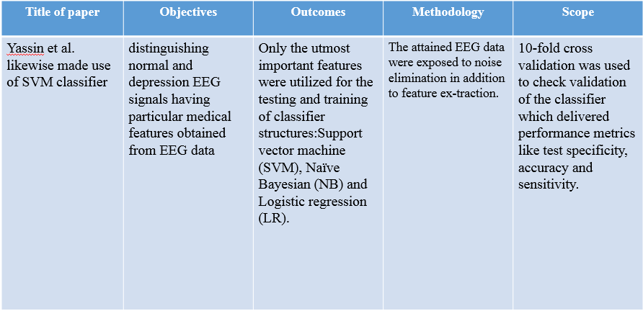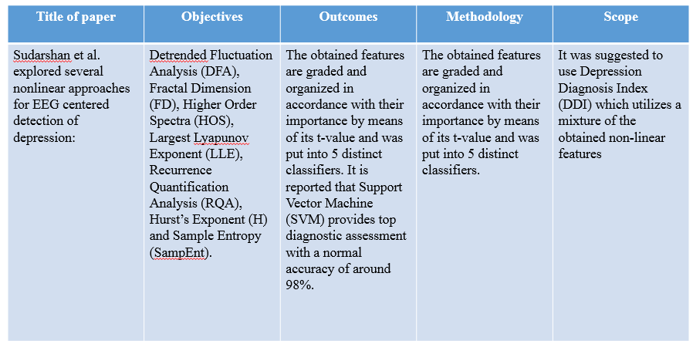

# CHAPTER 4 METHDOLOGY

**&**

**BLOCK DIAGRAME**

## METHODOLOGY :

## Deep learning is a machine learning method that enables computers to learn by example just like how humans teach themselves.

## Most of the EEG software was found to incorporate some form of abnormality detection algorithm.

## A multi-layer deep convolution neural network (CNN) is designed and developed to classify depression based on severity into three classes: mild, moderate and major.

## BLOCK DIAGRAM

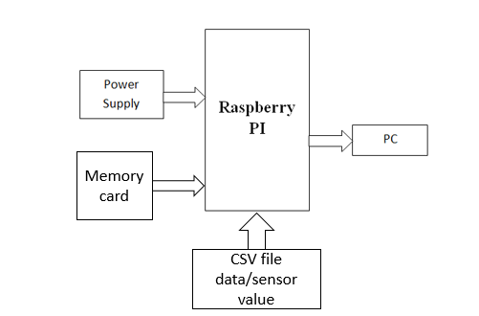

**RASPBERRY Pi-**

* + Raspberry Pi is the name of a series of single-board computers made by the [Raspberry Pi Foundation](https://www.raspberrypi.org/about/).
* The Raspberry Pi launched in 2012, and there have been several iterations and variations released since then. The Raspberry Pi has a single-core 700MHz CPU and just 256MB RAMA, and the latest model has a quad-core 1.4GHz CPU with 1GB RAM.
* All over the world, people use Raspberry Pi to learn programming skills, build hardware projects, do home automation, and even use them in industrial applications.
* The Raspberry Pi is a very cheap computer that runs Linux, but it also provides a set of GPIO (general purpose input/output) pins that allow you to control electronic components for physical computing and explore the Internet of Things (IoT).

**PYTHON-**

* Python works on different platforms (Windows, Mac, Linux, Raspberry Pi, etc).
* Python has a simple syntax similar to the English language. Python has syntax that allows developers to write programs with fewer lines than some other programming languages.
* Python runs on an interpreter system, meaning that code can be executed as soon as it is written.
* This means that prototyping can be very quick.
* Python can be treated in a procedural way, an object-oriented way or a functional way.

**FLOW OF THE SYSTEM**

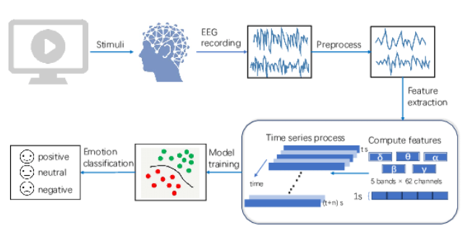

**CVS File Example**

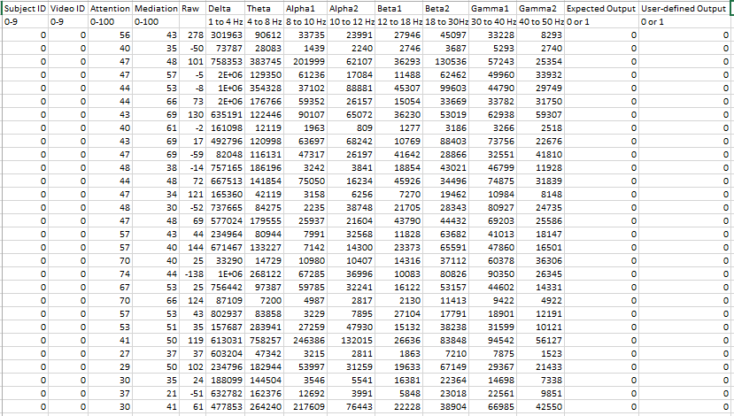

# CHAPTER 5 HARDWARE

**&SOFTWARE**

**REQUIREMENT**

## HARDWAREREQUIREMENT

* + - Raspberry pi
    - USB cable

## SOFTWAREREQUIREMENT

* + - Python language

# CHAPTER 6 MERITS

**&APPLICATIOS**

## ADVANTAGES :

* + Increase accuracy above 90%
  + cost reduction and reliable
  + Gives output immediately saves doctors efforts

# CHAPTER 7

**CONCLUSION AND**

**FUTURE SCOPE**

## CONCLUSION:

These system will improve the road safety as well as comfortable vehicle driving. By this technology people drive will be more comfortable and easier. Any problem occurred in our vehicle then our system will be informed to others so they can be aware of it while driving. It is efficient design for anti-collision of vehicle.

## FUTURE SCOPE:

In summary, the present study first illustrated that some abnormal organizations in the functional connectivity network of patients with depression also appeared in individuals with mild depression. Specifically, compared with healthy controls, the mild depression group has a larger characteristic path length and a lower clustering coefficient, indicating that the brain functional network of mild depression deviated from the small-world network. Second, we proposed a computer-aided method by which a CNN was used to learn information relevant to the functional connectivity matrices evident in individuals with mild depression such that they could be readily identified. This is an innovative approach other than the existing graph theory for the use of functional connectivity matrices for depression recognition. We primarily considered functional connectivity matrices that reflect altered brain functional connectivity in patients with mental illnesses using a 2D data structure given the advantages of CNNs in processing 2D datasets. The classification results of our method showed that coherence, correlation, and the PLV can effectively recognize mild depression using a CNN and that the recognition performance of coherence was superior to the other functional connectivity metrics, obtaining a classification accuracy of 80.74%. The proposed method can provide an auxiliary diagnosis of mild depression and offers great promise. In the future, we are committed to implement this method as an online depression detection system. Once an individual’s EEG signal is collected, it is used to determine whether the individual has mild depression, a disease that is not easily detectable and diagnosable. This approach may be used to improve and hasten the detection of individuals with mild depression, ultimately permitting quicker treatment.

While the present study offers significant benefits, it has some limitations that warrant discussion. First, in addition to the functional connectivity matrices used in the present study, there are other various connectivity metrics available, such as the imaginary part of coherency. Further investigation of these metrics and their ability to detect the signatures of mental illnesses such as depression must continue in the future. Second, we used the functional connectivity metrics generated by all 128 pairs of electrodes available to us here. It is necessary to further explore which electrodes most obviously dictate functional connectivity matrix differences between healthy control individuals and those with mild depression. This would allow greater reductions to the number of electrodes used for classification and pave the way for real-time, online depression detection.

# CHAPTER 8

**REFERANCES**

## WEBSITES

1. www.frontiersin.org/articles/10.3389/fnins.2020.00192/full#h6
2. https://www.researchgate.net/publication/331208554_EEG-based_mild_depression_recognition_using_convolutional_neural_network

## REFRENCES:-

S. C. Liao, C. T. Wu, H. C. Huang, W. T. Cheng, “Major depression detection from EEG signals using kernel eigen-filter-bank common spatial patterns,” Sensors 17 (6) (2017) 1385.

S. Ghosh-Dastidar, H. Adeli, N. Dadmehr, “Principal component analysis – enhanced cosine radial basis function neural network for robust epilepsy and seizure detection,” IEEE Transactions on Biomedical Engineering 55 (2) (2008) 512-518.

L. Khedher, L. A. Illan, J. M. Gorriz, J. Ramirez, A. Brahim, A. Meyer-Baese, “Independent component analysis – support vector machine-based computer aided diagnosis system for Alzheimer’s with visual support,” International Journal of Neural Systems 27 (3) (2017) 1650050 (8 pages).

S. L. Oh, Y. Hagiwara, G. M. Bairy, S. D. Puthankattil, O. Faust, U. C. Niranjan, U. R. Acharya, “Automated diagnosis of depression electroencephalograph signals using linear prediction coding and higher order spectra features,” Journal of Medical Imaging and Health Informatics 7 (8) (2017) 1857-1862.

# CHAPTER 9

**CODING**

**TEST CODE-**

import numpy

from sklearn.svm import SVC

from sklearn.model_selection import train_test_split

from sklearn.metrics import confusion_matrix

from sklearn.metrics import accuracy_score

from sklearn.ensemble import RandomForestClassifier

import joblib

import tkinter

from tkinter import filedialog

import os

#from pygame import mixer # Load the popular external library

import time

#mixer.init()

root = tkinter.Tk()

root.withdraw()

while True:

currdir = os.getcwd()

file = filedialog.askopenfilename()

a = numpy.genfromtxt(file, delimiter=' ')

a=a.reshape(1,-1)

clf=joblib.load('valance.pkl')

val = int(clf.predict(a))

clf=joblib.load('Arousal.pkl')

aro = int(clf.predict(a))

if val==0 and aro==0:

print('Sad')

if val==0 and aro==1:

print('Depressed')

if val==1 and aro==0:

print('Relaxed')

if val==1 and aro==1:

print('Happy')

**SVM CLASSifier-**

import numpy

from sklearn.svm import SVC

from sklearn.model_selection import train_test_split

from sklearn.metrics import confusion_matrix

from sklearn.metrics import accuracy_score

from sklearn.ensemble import RandomForestClassifier

import joblib

def svm_classifier():

file_x = 'data/features_sampled.dat'

file_y = 'data/label_class_0.dat'

X = numpy.genfromtxt(file_x, delimiter=' ')

y = numpy.genfromtxt(file_y, delimiter=' ')

# Split the data into training/testing sets

X_train, X_test, y_train, y_test = train_test_split(X, y, test_size=0.1, random_state=100)

# Feature Scaling

from sklearn.preprocessing import StandardScaler

sc = StandardScaler()

X_train = sc.fit_transform(X)

X_test = sc.transform(X)

for i in range(0,len(X_train)):

v=str(i)

fn='Test data/'+v+'.txt'

#print(X_train[i])

c = numpy.savetxt(fn, X_train[i], delimiter =', ')

# SVM Classifier

clf = SVC()

#clf = RandomForestClassifier(n_estimators=10)

print(X_train)

clf.fit(X_train, y)

y_predict = clf.predict(X_train)

#print(y_predict)

joblib.dump(clf, 'valance.pkl')

cm = confusion_matrix(y, y_predict)

print("Accuracy score of Valence ")

print(accuracy_score(y, y_predict)*100)

###############################################################

file_x = 'data/features_sampled.dat'

file_y = 'data/label_class_1.dat'

X = numpy.genfromtxt(file_x, delimiter=' ')

y = numpy.genfromtxt(file_y, delimiter=' ')

# Split the data into training/testing sets

X_train, X_test, y_train, y_test = train_test_split(X, y, test_size=0.1, random_state=42)

# Feature Scaling

from sklearn.preprocessing import StandardScaler

sc = StandardScaler()

X_train = sc.fit_transform(X)

X_test = sc.transform(X)

# SVM Classifier

clf = SVC()

clf.fit(X_train, y)

y_predict = clf.predict(X_test)

cm = confusion_matrix(y, y_predict)

joblib.dump(clf, 'Arousal.pkl')

print(cm)

print("Accuracy score of Arousal ")

print(accuracy_score(y, y_predict)*100)

if __name__ == '__main__':

svm_classifier()